**Variables in Postman:**

Variables and there scope in Postman

The below are the global and local variables.

The below is the collection level variable creating here the URL is declaring in collection level and can use within the collection any where.

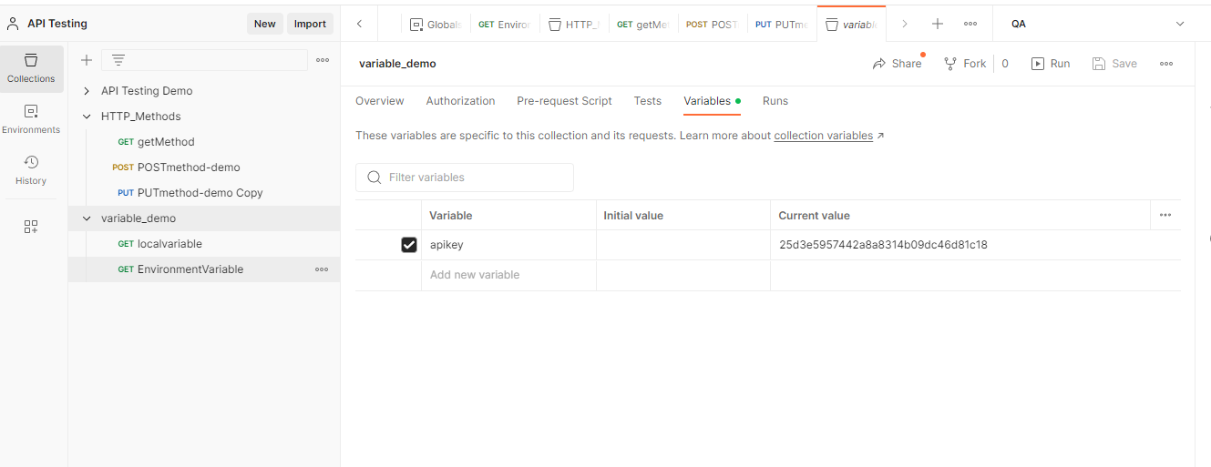

The below two are two environment variables and we can use the variable by selecting the environment in request.

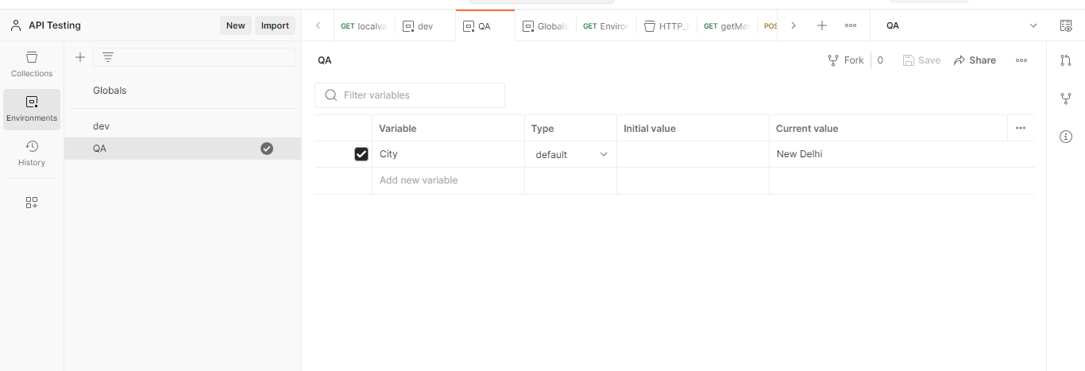

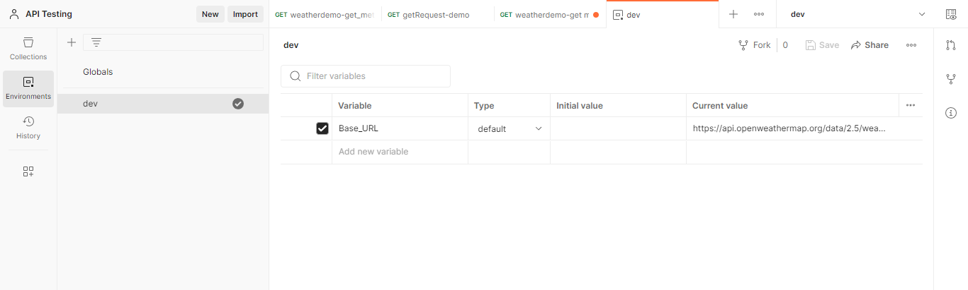

For the first request the variable for city the value is created in environment but the local variable is created for the same, so the local variable will get executed.

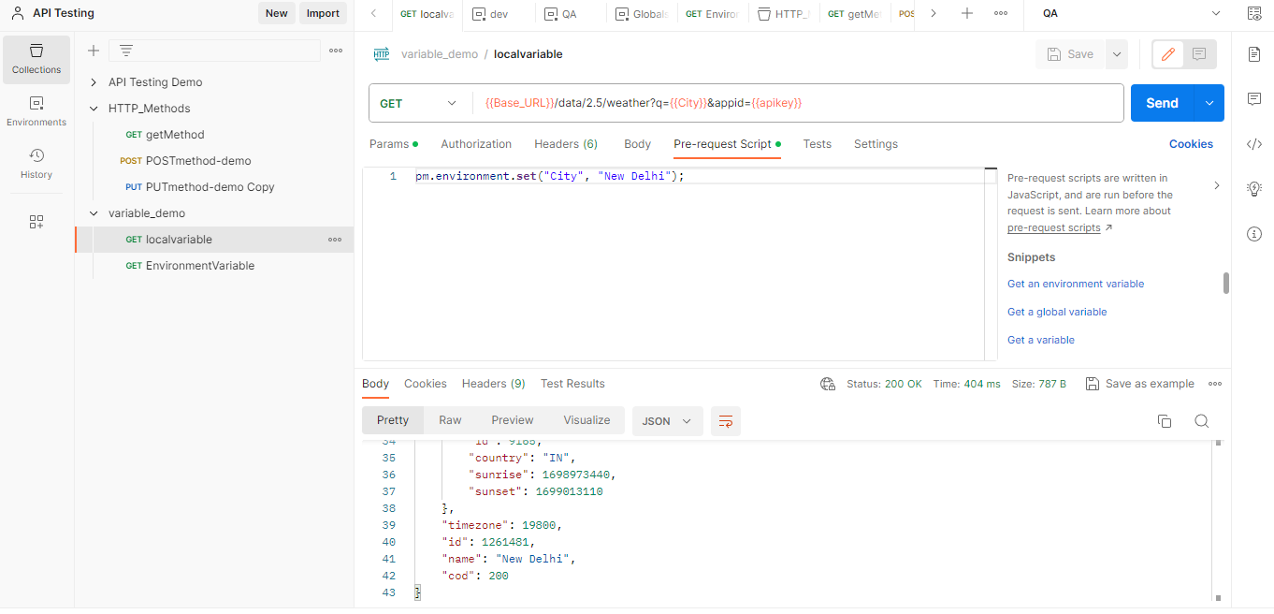

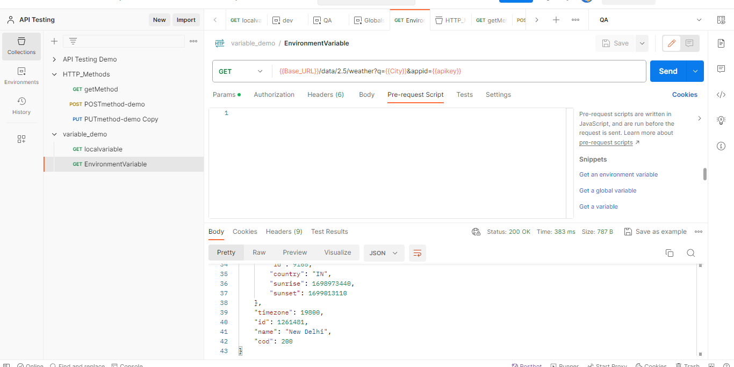

As we can see above the data for the given city is successfully fetched.